To Allow Kafka brokers outside cluster

1. Do the below changes in values.yaml make vale true from false.



1. Changes service type to Node port .



1. Add available ports based on pod replica.

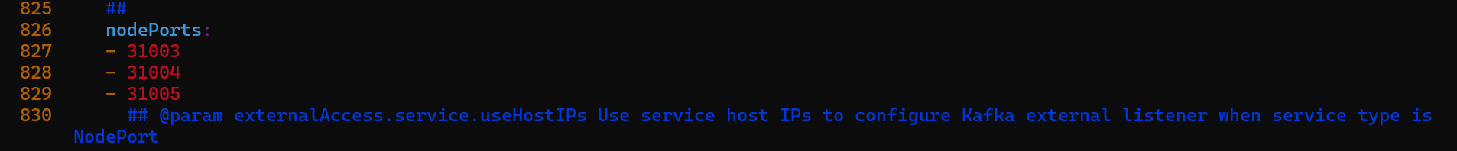

1. Change value of host ip from false to true, this will make entry in server. Properties file of each pod with respective Node ip on config file.

